The Watermill Theatre
Guide to Online Booking for Access Services

The following Access Services are available to book online:

Audio Described & Touch Tour (AD)
British Sign Language (BSL)
Closed Captioning (CC)
Relaxed Performances (RP)

In order to book Access Services online you will need an online account with your personal booking preferences selected.

Follow the steps below to:

- Set up an online account
- Update your preferences
- Select your preferred seats
- Reserve Access Service Equipment free of charge

Setting up your online account

In order to book online you will need an online account. If you have booked online before it is likely you already have an account with us.

Follow the steps below to login or set up a new online account to activate online booking.

- Go to our website: www.watermill.org.uk - this link will take you to our homepage

- In the top right-hand corner of the screen, you will see these options:

- Click on ‘My Account’ to be taken to the login screen:

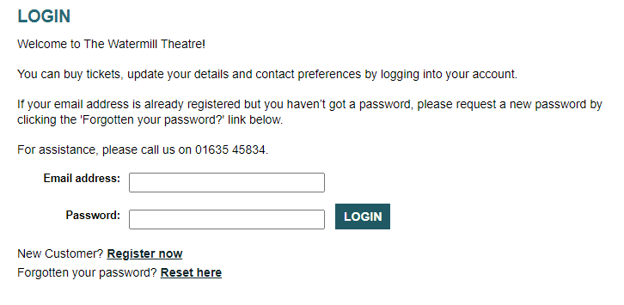

- Enter your email address and password to login or select ‘Register Now’ to create a new account. If you think you already have an account but can’t remember your password, click ‘Reset Here’ to be sent a password reset email.

Updating your preferences

- Once you are logged into your account you will see this page:

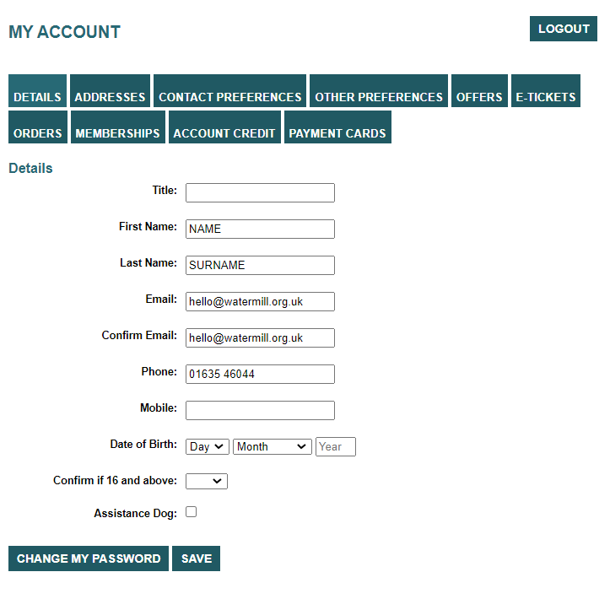

- Click on ‘Other Preferences’ to be taken to this page:

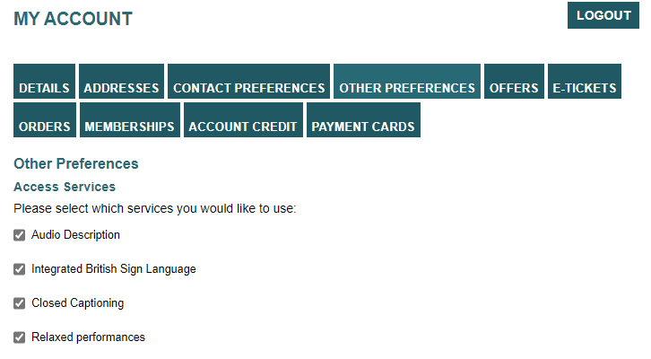

- Select the box for whichever service you would like to book online. This will also mean you will receive bespoke emails and information about your selected services.

- Once you have selected your preferences make sure you click SAVE at the bottom of the page to ensure your access service preferences are updated.

Booking tickets

You should now be logged into your online account with your access service preferences saved. This means you are now able to book tickets with access services online.

- Go to the ‘What’s On’ page to see what’s coming up at the theatre.

- Click ‘BOOK NOW’ on your preferred show to be taken to the booking page:

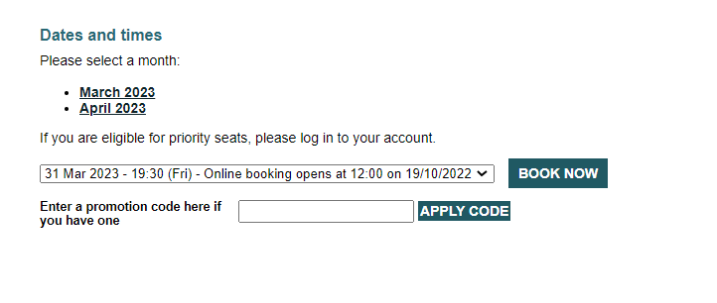

- Click on the dropdown to select your chosen date. Details of when access services are available can be found on the event page or on the ACCESS PERFORMANCE DIARY page.

- Once you have selected your preferred performance date you will be taken to the seating plan. The best seats for the accessible performance will be displayed as stars, as pictured below. These seats will give you the best possible experience of the service on offer.

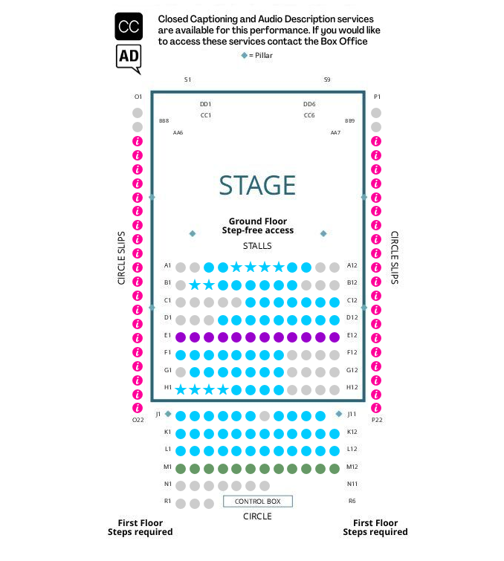

- Click on your chosen seat and a green ticket will appear to show it has been selected.

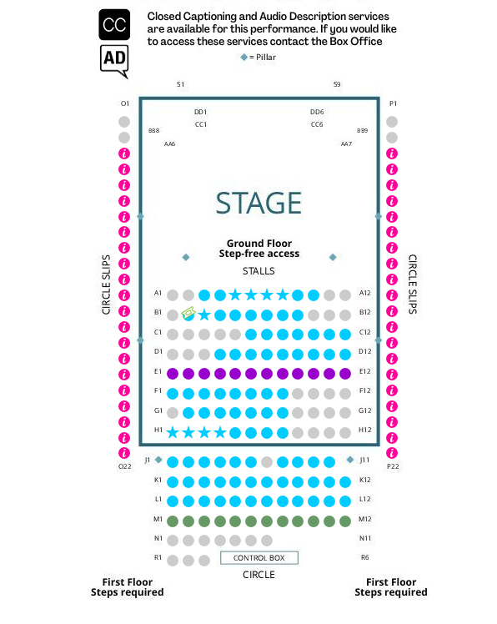

- Once you have selected your seats click CONTINUE to continue the booking journey.

Access Service Equipment

Specialist equipment is required in order to access Audio Description and Closed Captioning services. You will be presented with an option to reserve this equipment before you complete your booking:

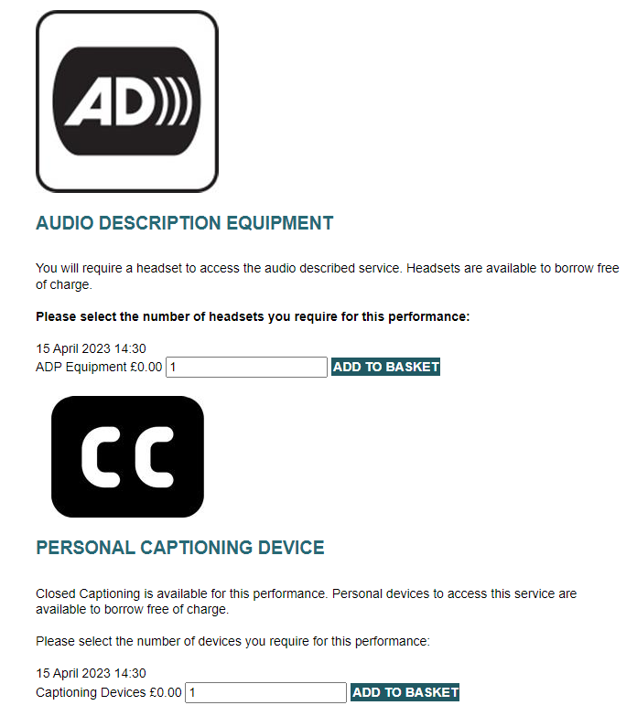

Further Information

For more information about access at The Watermill, including details about the facilities at the theatre, please visit watermill.org.uk/access

If there is anything you would like to discuss with us or if you require any support with booking online, the Box Office team are available to help 12pm-6pm every day.

Call us on 01635 46044 or email boxoffice@watermill.org.uk

